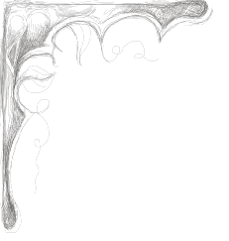
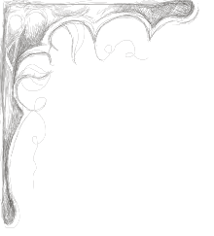
Thunderhead Lodge
We label our items for those with special culinary needs when applicable.
Our regular fries, sweet potato fries, and potato chips are fresh hand cut.
GF = Gluten Free, LC = Low Carbohydrate, VG = Vegetarian, SH = Shellfish Allergy, TN = Tree Nut Allergy.
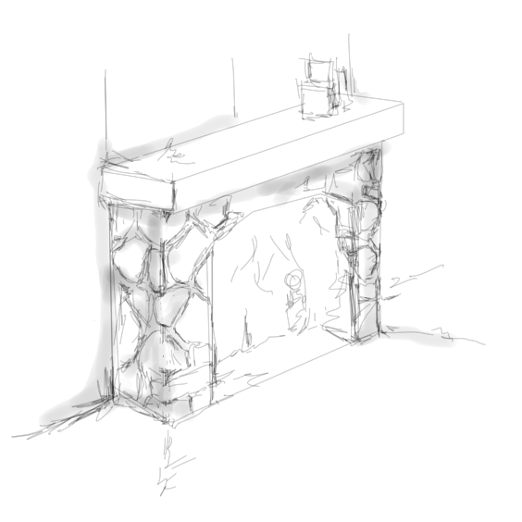
Appetizers/Soups/Salads

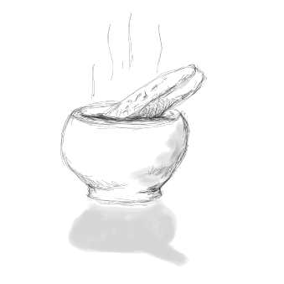
French Onion Soup 8
Soup du Jour 8
Regular Fries with Zesty Dipping Sauce VG 6
Sweet Potato Fries with Sweet Chipotle Aioli Dipping Sauce VG 6
Loaded Fries 14
Fries topped with pulled pork, cheddar cheese, scallions, tomatoes, and sour cream.
Thunderhead Wings 13
BBQ garlic | Buffalo |Garlic Parmesan | Sweet Thai Chili |
*Celery and buttermilk ranch or house made bleu cheese 1
Thunder Shrimp GF SH 14
Jumbo shrimp sauteed in a special spicy sauce, served with coleslaw
Fried Mozzarella wedges with marinara VG 11
Crab Spinach Dip with tortilla chips SH 15
Bavarian Pretzel VG 6
Served with whole grain creamy mustard sauce
Thunder Nuts GF TN VG 9
House Salad GF VG 7
Chopped Romaine, Arugula, and Radicchio, mixed with grape tomatoes and cucumbers, tossed with our signature house dressing.
Caesar Salad* VG 9
A classic salad of romaine lettuce hearts, parmesan cheese and croutons, tossed with our original Caesar dressing.
Chili Lime Chicken Fiesta Salad 16 GF LC
Grilled zesty chicken breast, tomatoes, green onions, avocado, sharp cheddar cheese, bacon and chipotle lime dressing.
The Cobb 16 GF LC
Grilled chicken breast, tomatoes, avocado, bacon, roasted corn, bleu cheese crumbles, on a bed of crisp romaine lettuce. Served with buttermilk ranch dressing.
The Greek 13 GF LC VG
Feta cheese, bell peppers, red onion, kalamata olives, tomatoes, cucumbers, mixed with house salad lettuce blend and our signature house dressing.
Salad Additions
* Grilled Shrimp SH 7 * Salmon Filet 13
* Grilled Chicken 6 * Crab Cake SH 15

Sandwiches/Bistro Plates

Thunder Burger 15
- 8 oz. hand pressed fresh ground beef, lettuce, tomato, and grilled red onion served on toasted brioche bun. Served with hand cut fries.
Add bacon 2
Add cheese, sautéed mushrooms fried egg, pickled jalapenos, crispy fried onions 1 each
Cheese options: American, Bleu, Cheddar, Swiss, Pepper Jack
The Mother Lode 16
Grilled smoked ham, parmesan & gruyere cheese sauce sandwich, topped with gruyere cheese and then baked. Served with hand cut fries.
- Add a fried egg 1
The Buford 14
BBQ pulled pork, crispy fried onions and BBQ sauce served on toasted brioche roll with garlic mayo. Served with a side of coleslaw.
Chili Lime Chicken Sandwich 14
Grilled zesty chicken breast, lettuce, tomato, chipotle lime dressing, on a toasted brioche bun. Served with house made chips and a pickle.
Fish & Chips 19
House made Yuengling battered 8 oz cod, fresh cut fries, served with house made tartar sauce and coleslaw

Spicybird 14
Spicy buttermilk fried chicken thighs, pepper jack cheese, lettuce, tomato, pickled jalapenos, chipotle aioli, served on brioche with house made chips and a pickle.
Crab Cake Sandwich SH 19
Broiled Maryland style crab cake served on toasted brioche bun with crunchy slaw, pickled red onions, and a chipotle aioli. Served with sweet potato fries and pickle.
Chicken Pot Pie 14
Roasted chicken combined with carrots, potatoes, celery, onions, corn, and peas in a rich cream gravy, topped with a savory house made crust.
Cheesy Spinach Casserole GF VG 14
Baked spinach and rice casserole with eggs, milk, onion, cheddar and gruyere cheeses.
Kids Menu (12 and under)
Grilled American Cheese 7
Chicken in a Basket 8
Buttered Noodles 6
Served with choice of French Fries, Chips, Carrots, or Apple Slices
- Additional Sauces/Dressings 1, Substitute Fries 3, Substitute Gluten Free Roll 2

