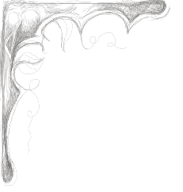
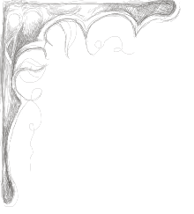
Sunday Brunch – 11AM- 2PM
We label our items for those with special culinary needs when applicable.
GF = Gluten Free, LC = Low Carbohydrate, SF = Sugar Free, VG = Vegetarian, SH = Shellfish Allergy, TN = Tree Nut Allergy.

- The Classic Benedict 13
2 poached eggs, Canadian bacon, hollandaise on English muffins served with breakfast potatoes.
- Crab Benedict SH 17
2 poached eggs, lump crab meat, hollandaise on English muffins served with breakfast potatoes.
- Pulled Pork Benedict 13
pulled pork, 2 fried eggs, hollandaise on English muffins served with breakfast potatoes.
- Cowboy Benedict 13
Buttermilk biscuits, white sausage gravy, topped with 2 fried eggs, served with breakfast potatoes.
- Thunderhead Rancheros VG 13
Eggs, tomatoes, onions, black beans, roasted corn, corn tortillas, with a southwest flair.

Braised Short Rib Hash 17
Braised short rib, potatoes, red onions, peppers, scallions, cheddar, topped with 2 fried eggs.
- Burger Benedict 19
8 oz. hand pressed fresh ground beef, Canadian bacon, fried egg, hollandaise sauce, on a toasted brioche bun. Served with breakfast potatoes.
- Steak & Eggs 21
Prime Rib topped with 2 fried eggs, served with breakfast potatoes.
Seasonal Frittata 13
Served with breakfast potatoes and English muffin.
French Toast VG 9
Classic Cream Scones VG 9
Classic English fresh baked cream & fruit scones served with jam

Brunch Specialty Cocktails/Coffee & Espresso Drinks

Pumpkin Spiced Coffee 8
Thunder Bloody 9
Mimosa Sunrise 11
Coffee (Regular/Decaf) 3
Cappuccino 5
Espresso 3

